CARRIAGEWORKS DELIVERY NOTICE

DELIVER TO:
CARRIAGEWORKS

229 WILSON STREET
EVELEIGH NSW

LOADING DOCK
DELIVERY INSTRUCTIONS:
Always ring delivery contact upon approach.
CARRIAGEWORKS SENIOR TECHNICIAN: 0411 257 101
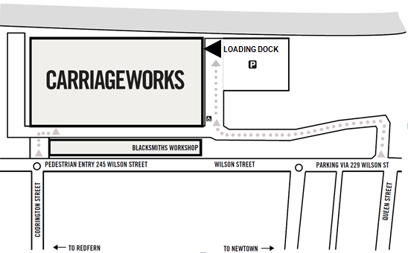

SENT BY:
COMPANY NAME
Contact Name
Mobile Phone Number
Name of Project
Courier Company Contact #
Date of Delivery
Number or Items /Boxes

